NAME:………………………………………………………CLASS................ ADM NO..........

Kenya Certificate of Secondary Education
FORM 3
MATHEMATICS
PAPER- JUNE/JULY
TIME: 2 ½ HOURS

INSTRUCTIONS TO CANDIDATES.
1) Write your name and index number in the spaces provided above.
2) Sign and write the date of examination in the spaces provided above.
3) This paper consistsof twosection I and II.
4) Answer ALL questions in sectionIand only five questions from section II.
5) Answers and working must be written on the question paper in the spaces provided below each question
6) Marks may be given for correct working even if the answer is wrong
7) Non-programmable electronic calculators may be used.

FOR EXAMINERS’ USE ONLY

SECTION I
1 | 2 | 3 | 4 | 5 | 6 | 7 | 8 | 9 | 10 | 11 | 12 | 13 | 14 | 15 | 16 | TOTAL

SECTION II
Grand
Total
17 | 18 | 19 | 20 | 21 | 22 | 23 | 24 | TOTAL

This paper consists of 12 printed pages.
Candidates should check the question paper to ascertain that all pages are printed as indicated and no questions are missing.

SECTION I (50 MARKS)
Answer ALL Questions from this section in the spaces provided

1 Use logarithms to evaluate (4mks)

2 Make 4 the subject of the formula.
(3mks)

…
3 Express the recurring decimal below as a fraction; 4.372 leaving your answer in the form of ª/_{b} where a and b are integers. (2mks)

4. Translation Q is represented by the column vector and another translation R by the column vector. A point S is mapped onto a point T by Q and a point T is mapped into a point U by R. If point U is (8, - 4), determine the co-ordinates of point S. (3mks)

5 . Find the values of a and b (4mks)

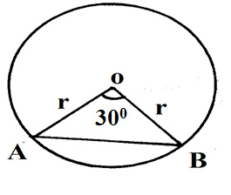
6. The figure below shows a circle centre O. Chord AB subtends 30⁰ at the centre. If the area of the minor segment is 5.25cm², find the radius of the circle. (3mks)

7. The position vectors for points A and B are 2i + 5j + 3k and 4i – 7j + 3k respectively. Express vectors AB in terms of unit vectors i, j and k. Hence find the length of AB leaving your answer in simplified surd form 3marks

8 Given that the matrix has no inverse, find x. (2mks)

9 In the figure below ABC is a tangent to the circle at point B.Given that BE =6.9cm, FE=7.8cm, GE=4.1cm, DC=11.2cm and ED = xcm.Determine the length BC; give your answer in four significant figures. (4mks)
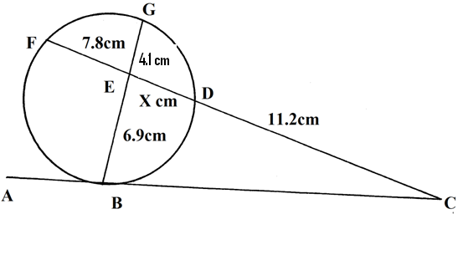

10 Given that matrix , Find matrix such that: A² =+ (3mks)

11 A quantity P varies partly as t and partly as the square of t.When t = 20, p = 45 , and when t = 24 , p = 60.
a) Express p in terms of t. (2mks)

b) Find p when t = 32. (2mks)

12 Achang’a deposited sh. 20 000 in a saving account. Find the interest after two years. If the interest was paid at 16% per annum compound semi-annually. (3mks)

- Using a ruler and a pair of compasses only construct triangle ABC such that BC=6cm, <ABC=75º and BCA=45º. Drop a perpendicular to BC from A to meet BC at O hence find the area of triangle ABC (4 mks)

14 Five men working 8 hours daily complete a piece of work in 3 days. How long will it take 12men working 5hours a day to complete the same work. (2mks)

15 Find the integral values of x which satisfy 6 < 2x + 1 and 5x – 29 < - 4 . (3mks)

16 In a fund-raising committee of 45 people, the ratio of men to women is 7: 2.Find the number of women required to join the existing committee so that the ratio of men to women changes to 5:4. (3mks)

SECTION II (50 MARKS )
Attempt any five questions from this section

17. James’ earning are as follows:- Basic salary 38,000 p.m, House allowance Sh. 14, 000p.m Travelling allowance Sh. 8,500p.m. Medical allowance sh. 3,300
The table for the taxable income is as shown below
Income tax in k£ p.a | Tax in Sh. Per pound
1 – 6000  6001 – 12000  12001 – 18000  1001 – 24 000  24001 - 30 000  30001 - 36000  36001 – 42 000  42001 – 48 000  Over 48 000 | 2  3  4  5  6  7  8  9  10

(a) Calculate Jame’s taxable income p.a (2mks)

(b) Calculate Jame’s P.A.Y.E if he is entitled to a tax relief of Sh. 18 000 p.a(4mks)

(c) James is also deducted the following per month:-
NHIF Sh. 320
Pension scheme Sh. 1000
Co-operative shares Sh. 2000
Loan repayment Sh. 5000
Interest on loan Sh. 500
(i) Calculate James’ total deduction per month in Ksh. (2mks)

(ii) Calculate his net salary per month. (2mks)

18. In the figure below, ABCD is a square.Points P,Q,R and S are the midpoints of AB,BC,CD and DA respectively.
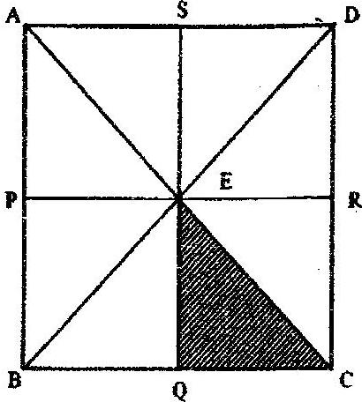

(a).Describe fully:
- A reflection that maps triangle QCE onto triangle SDE. (1mk)

- An enlargement that maps triangle QCE onto triangle SAE. (2 mks)

- A rotation that maps triangle QCE onto triangle PEB. (3 mks)

(b).The triangle ERC is reflected on the line BD. The image of ERC under the reflection is rotated clockwise through an angle of 90⁰ about P.
Determine the images of R and C:
- Under the reflection ( 2mks)

- After the two successive transformations ( 2mks)

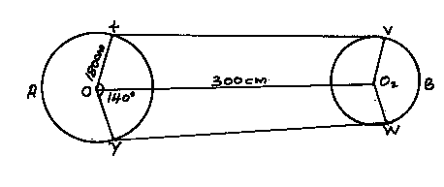
19. The figure below shows a pulley system where a conveyor belt is tied round the two wheels. The radius of the large wheel is 180cm and the distance between the centres of the wheel is 300cm and XOY = 140⁰

Determine
(a) Length XV (2mks)

(b) Length VBW (3mks)

(3mks)
(c) Length XAY

(2mks)
(d) The total length of the conveyor belt

- From Jane’s home, her school is 150m on a bearing of N60ºE. The shopping centre is on a bearing of 150º from the school and 110º from Jane’s home. The church she attends is 180 m from her home on a bearing of 320º.. Using a scale of 1cm to represent 30m
- Show the relative positions of the four points (4mks)
- Use the drawing to determine
- The distance of the school from the shopping centre (1mks)
- The distance of her home from the shopping centre (1mks)
- The distance and bearing of the church from the shopping centre (2mks)
- The distance and bearing of the school from the church (2mks)

21. P varies directly as V and inversely as the square root of R. Given that P = 180, R = 25 when V = 9.
(a) Find P when V = 6 and R = 26. (3 marks)

(b) Find the value of V when P = 360 and R = 0.64. (3 mks)

(c) If V increased by 16% and R decreases by 25%, find the percentage change in P. (4mks)

22. a) Complete the table below. (2mks)
x | -30 | 0 | 30 | 60 | 90 | 120 | 150 | 180 | 210 | 240 | 270
Sin (x+30) | 0 | 0.50 |  | 1.00 | 0.87 |  |  | -0.50 |  |  | -0.87
Cos ( x-15) | 0.71 |  | 0.97 |  | 0.26 |  |  |  | -0.97 | -0.71 | -0.26

b) Draw the graph of y = sin (x+30) and y=cos(x-15) for -30≤X≤270⁰on the same grid. Take 1cm to represent 30º on x-axis and 1cm to represent 0.2units on y-axis. (5 mks)

- Using your graph drawn (b) above
- Find the values of x for which cos (x-15) –sin (x+30) = 0 (2mks)

- Estimate the angle corresponding to cos(x-15) = 0.6. (1 mk)

23. A tailor bought a number of suits at a cost of sh 57600 from Jimco clothing. Had he bought the same suits from Gikondi clothing, it would have cost him sh 480 less per suit. This would have enabled him to buy 4 extra suits for the same amount of money.
If x represents the number of suits bought;
- Write an expression of the cost per suit bought from
- Jimco clothing (1mk)

- Gikondi clothing (1mk)

- Form an equation in x and determine the number of suits the tailor bought (4mks)

- The tailor later sold each suit for sh 720 more than he had paid for it. Determine the percentage profit. (4mks)

24. a) The first term of an arithmetic progression (AP) is 2. The sum of the first 8 terms of the AP is 256.
i) Find the common difference of the AP (2mks)

- Given that the sum of the first n terms of the AP 416, find n (2mks)

b) The 3rd, 5th, and 8th terms of another AP forms the first three terms of a geometric progression (GP).If the common difference of the AP is 3.
Find
- The first term of GP (4mks)

- The sum of the first 9 terms of the GP to 4 s.f (2mks)

